BOG(BeOurGuest) Web Application
Project Proposal
January 29th, 2019

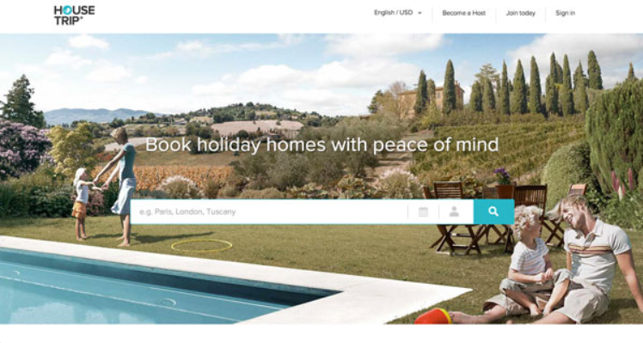

*This Image is used for example purposes only*

Submitted by: Robert Palumbo, Valerie Duran, Kiana Vigil

Description
BeOurGuest (BOG) is a web application that provides a variety of vacation rentals from trusted home owners. Our platform allows home owners to use our service to profit from travelers who would rather be comfortable in their own spacious home, rather than staying at a hotel with limited space. As a startup company, it is our duty to approve and perform background checks on all home owners for the safety of our customers. Our goal is to eliminate the frustration of business for both the customer and home owner. Making it easier on the customer to compare homes and prices, and for the home owners to get a guarantee customer base from our marketing strategies. We want our customers to choose their own style of vacation home, whether they be on business or personal travel at a low cost, competing with the highly rated hotels in the area. BOG is designed to be a one stop application that handles all your travel lodging needs, beginning to end, in a clean, simple, and efficient manner

Functionality
Users will create an account with a secure password, which will be added to a database. Once a user logs in with authenticated credentials, they can make reservations, add listings for future reference, and view their account information. Users will be able to add/delete/modify payment information that is listed on their account. Users will utilize the search function to be able to find the rental listing that fits their accommodation. You can search by zip code or city, state. Once the user finds a listing of interest, they will have the option to view dates in which the vacation rental is available. The user can then proceed to the reservations page. At this page they can check out with their credit card and this will ensure reservation. They will then be directed to a confirmation page. Users also have the opportunity to add a listing of their own. They would do this using their same account.
Functionality for admin accounts will consists of allowing full control over any data on the website. Admin accounts can modify and delete listing but will not be able to reserve a listing or add a listing. Deletion of an account can only be performed by the Admin account. Admin accounts can also fix any issue that users may have.

Business Rules
ADMIN
•Admin must ensure secure credentials of users
•Admin must provide user-friendly front-end support
•Admin must have access to all data
•Admin cannot store credit card information
•Deleting of accounts can only be done by Admin

•Credit Card expiration data must be in the future
•User cannot book a rental that is already booked
•Cannot book rental with expired credit card

USER
•User must have an active account
•User must sign in to book/lease rental
•User must search for listing
•User must user must select dates and rental preference
•User must use pay with credit card to reserve rental
•User must provide price per night
•User must provide rental information (# of rooms, bathrooms, sleeps)
•User must provide available dates
•User must provide check in/out times, house rules

Web Pages
For this project we will display 8 webpages, including additional webpages which will display details of a specific vacation home. Home Page, Login Page, Search Page, Results Page, Customer Account Page, Confirmation Page, Admin Page, and Listing Page.
Anybody with internet access can view the home page contents of this webpage, as well as performing actions such as search and view listings available on the webpage. The home page will display all of our customer available page links at the top of the page and will display 2 different options that gives a user access to location listings. The first option will display a search bar located at the top banner of the home page. When using the search tool, the user will only see a select option of vacation rental locations. The search bar will redirect the user to the results page, which will display all the available rental listings for that precise location. The second option will be a display of designed location title boxes under the search bar, with all the select locations BOG plans to provide. In the second option, the users will be able to click on a designed location title box which will redirect them to the results page as well.
For a user to book and reserve a vacation home, they must have a customer account. Therefore, when a user would like to reserve a rental, they will be redirected to a login page. The Login page link can be accessed on the home page if the user decides to explore page with authenticated credentials. If the user does not have an account with BOG, then they will have the option to create an account on the Login page, which will then redirect the user to a customer account page. The customer account page will ask the user to input general information into a form, as well as payment methods. When a user with a customer account reserves a vacation rental, they will be redirected to a confirmation page. The confirmation page will give the user the ability to return to the home page once the customer has reviewed all the information.
Admins for BOG automatically have an account in the system, so there is no need for creating an account. The Admins of BOG will have elevated privileges, granting them access to different webpages that the user cannot access. These Pages will be the Admin Page and the Listing Page. The Admin page will have a secure view of listings, customer activity, and will have add/delete/modify capabilities. If the admin wishes to add detailed information such as home description and photos, then they will have the option to view/modify/save any data listed on the Listings page.

Validation
For this project there is a select amount of input data that will require validation. When asking for personal information on the forms, we will require that phone numbers must be 10 numeric digits. Only 5 numeric digits will be accepted for Zip codes, and 2 characters representing abbreviation for states. We will give the users an option of typing in the abbreviations or selecting from a drop-down menu.
When credit card information is necessary, we will require that only 15 numeric digits are accepted. If a user is under or exceeds this number, then the card is not a valid payment method. When credit card information is stored, we will void any card that has an expiration date older than present time. It is required that users input a first and last name, along with a valid 3 numeric digit security code.
Passwords will not be accepted if the user does not use at least one special character, one number, and one upper case letter. A user will view an error message until these requirements are met, including creating a password between 8 and 15 characters.
When a user tries to reserve a vacation rental, they will not be able to book anything before the current date, only dates in the future will be available for booking. The property type will be defined as: Home=0, Condo=1, Cabin=3. The default will be registered to Home(0). The number of bedroom and bathrooms will be labeled under the data type SMALLINT, requiring that the numeric digit should be greater that zero and less that 255.

Model Sites
For the purposes of this project, our team will be using the following web sites as models for the implementation of our BOG - Be Our Guest property rental website:
- VRBO® Vacation Rentals by Owner | Why Limit Yourself To Hotels
https://www.vrbo.com/

- Airbnb: Vacation Rentals, Homes, Experiences & Places
https://www.airbnb.com

Database Schema
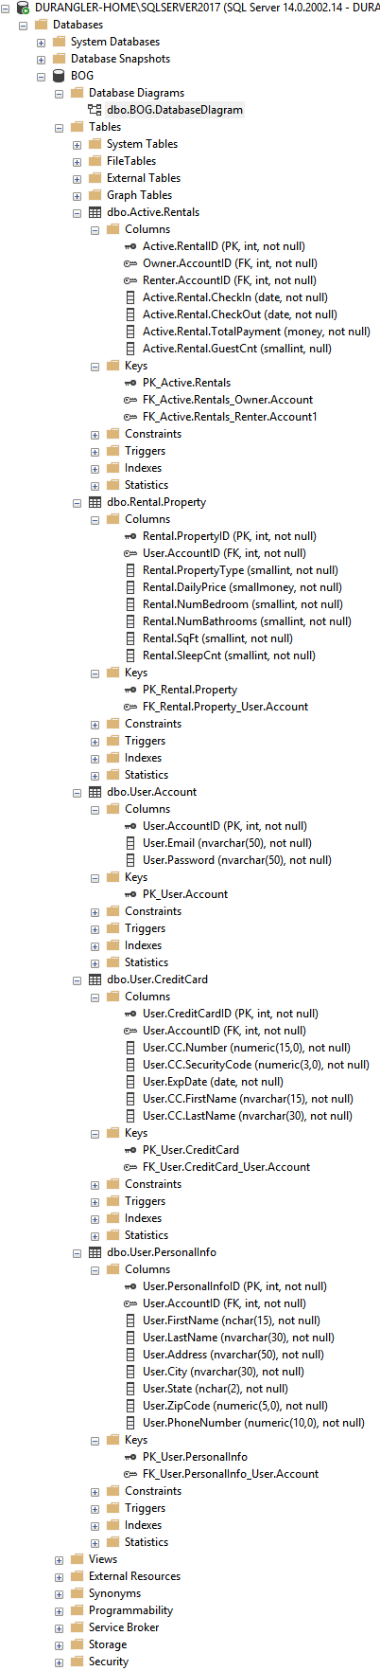

SQL Server DB Diagram
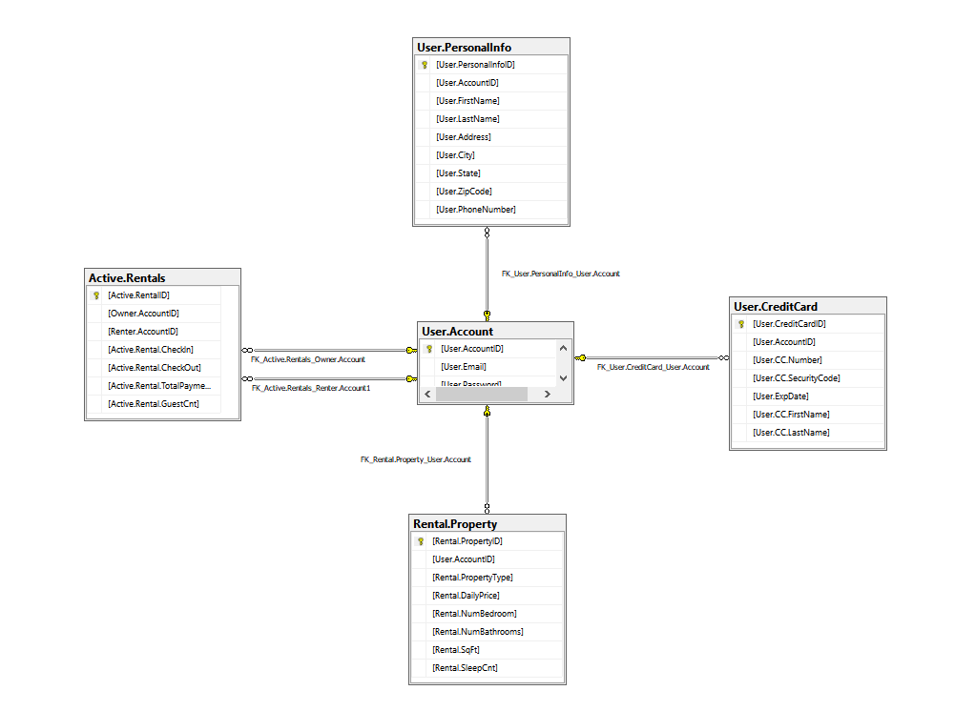

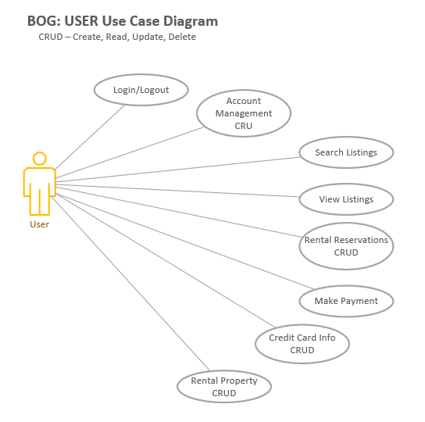
Pseudo Use Case Diagram
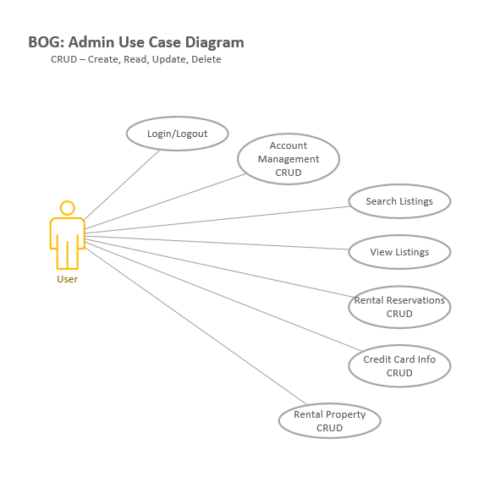

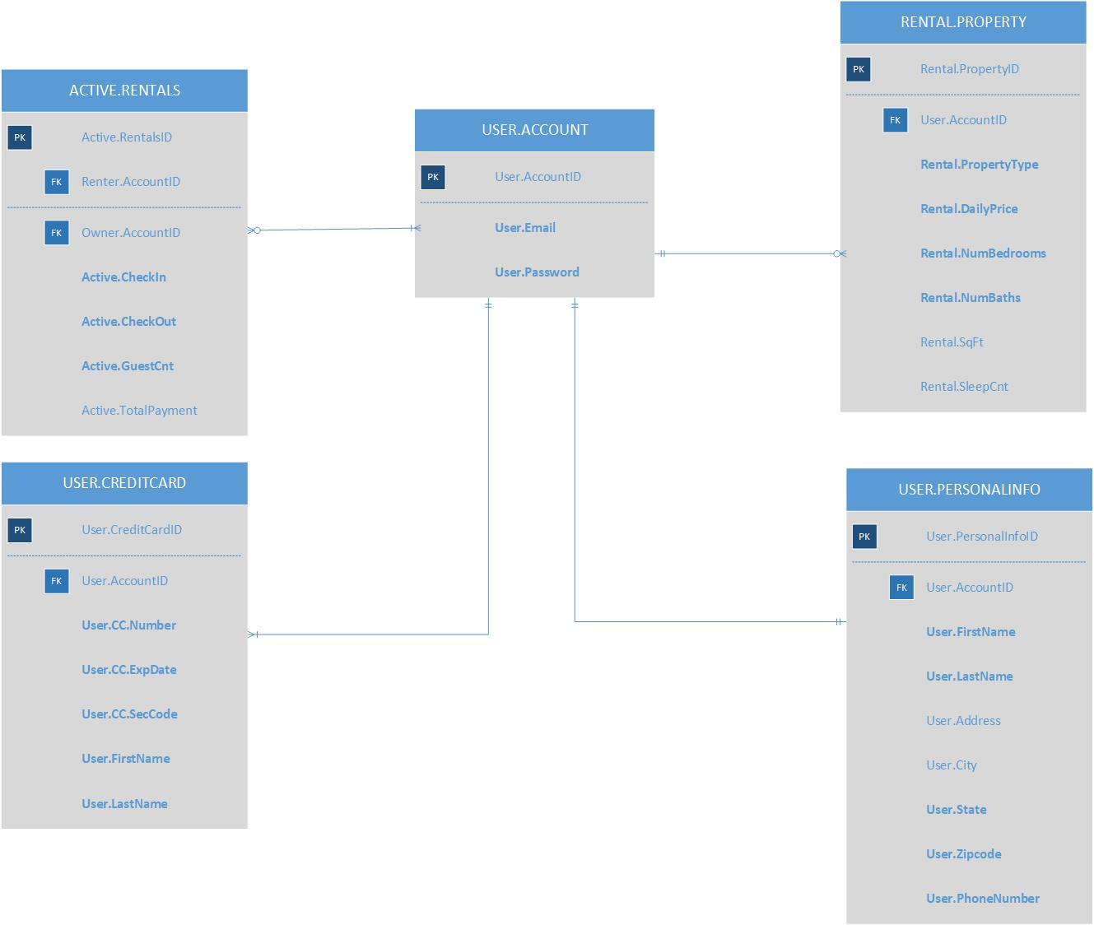
ERD Diagram

